Iperf3 network Tester
  - iperf3 Network Tester - An independent software-engineering research study
  - Room + KMP SQLite Persistence
Source: ROOMDBPLAN.md, branch roomdbkmp
Author: Jerry Abramson (with Claude Code)
Date: 2026-07-27
Status: Phase 1 Complete — implemented and manually verified on Android, iOS, and Desktop
Last Updated: 2026-07-27 (see Implementation Status section below)
Assistants: qwen/qwen3.6-35b-a3b + Claude Code
Local AI Detals: See Appendix A
Claude Code Details: See Appendix B
Local System Details: See Appendix C

Goal
Persist a completed ResultData run to a local SQLite database on all three targets (Android, iOS, Desktop), replacing the simulated delay(3.seconds) in Iperf3RunViewModel.saveResult() with a real Room insert, and read it back reliably — guid, timestamps, and numeric results all survive a round trip.
CSV export and a results-history/browse screen are explicitly out of scope for phase 1 (see Phasing). Getting one row saved and re-readable end-to-end on all three targets is the hard part; export/browsing are then straightforward additions.

Implementation Status (Updated 2026-07-27)
Phase 1 is complete and manually verified end-to-end on all three targets. saveResult() performs a real Room insert on Android, iOS (simulator and a real device-signed Xcode build), and desktop JVM. Each platform's actual database file was inspected directly (DB Browser for SQLite) after clicking Save, confirming correct data — not just that the build compiles.

What Was Built
Gradle wiring across all four modules: KSP + Room plugins, per-source-set SQLite driver artifacts (sqlite-framework-android on Android, sqlite-framework on iOS, sqlite-bundled on desktop), and per-target KSP codegen registration (kspAndroid / kspIosArm64 / kspIosSimulatorArm64 / kspJvm).
The database/ package: ResultDataEntity, ResultDataEntityDao (all suspend methods), ResultDatabase (Room's multiplatform @ConstructedBy pattern), ResultDataMappers, ResultDataRepository, and Database.kt’s expect/actual driver plus a per-platform lazy-singleton getResultDatabase().
AndroidAppContextHolder plus one line in MainActivity.onCreate() — the minimal way to give Room's Android driver a Context without a DI framework.
Iperf3RunViewModel reaches the repository through a lazily-constructed singleton, first touched inside saveResult()'s own coroutine — guarantees the database is built exactly once, off the main thread, without touching any of the three platform entry points beyond the Context-holder line. (This is a simpler alternative to the constructor-injection approach originally proposed.)
model/ResultData.kt, the old domain class fully superseded by ResultDataEntity, has been deleted.

Bugs Found and Fixed During Implementation
androidx.sqlite:sqlite-framework was placed in commonMain per the codelab's guidance, but that artifact publishes no jvm variant — broke :desktopApp:build with a dependency resolution failure invisible to the Android/iOS builds. Moved to per-target source sets instead.
AppUUID / AppLocalDateTime only expose a name: String property, no toString() override — code that called .toString() on them silently got Any's default (ClassName@hashcode) instead of the real UUID/timestamp, corrupting every saved row's guid. Fixed to use .name.
Room requires every DAO method to be suspend on non-Android targets; the DAO was originally written with plain blocking functions, which compiled fine on Android and only failed when the JVM/iOS KSP codegen ran.
Dispatchers.IO is not public for iosArm64/iosSimulatorArm64 under the kotlinx-coroutines-core version Room's own dependency graph resolves to here — switched to Dispatchers.Default, which is guaranteed public on all three targets.
fallbackToDestructiveMigration was never actually wired into the Room builder despite being called for in the plan; added it, and bumped the schema version to clear rows written under the guid-corruption bug above.
The Xcode app build failed at the final link step with undefined sqlite3 symbols even with Gradle's -lsqlite3 framework linker flag already set, because the shared framework is built as a static library — Xcode's own final app-link step needed its own -lsqlite3, added directly to the Xcode project's target build settings.

Remaining Work
No automated round-trip test yet (androidHostTest / jvmTest / iosSimulatorArm64Test) — manual verification confirmed correctness this round, but nothing guards against a future regression the way a test would.
ResultDataMappers.toDomain() is still an unpopulated stub — fine for now since nothing reads results back yet, but needed before Phase 2's history screen can display anything.
Phase 2 (CSV export, results-history screen) is not started.
shared/schemas/ (Room's exported schema JSON, one file per version) is ready to commit to git — Room's own convention for a diffable schema history.

Preliminary Exercise
The Initial planning had utilized a code lab exercise to convert a roomdb Android App to KMP.
Migrate Room To KMP codelab: "Fruitties" shopping app
- https://developer.android.com/codelabs/kmp-migrate-room
This exercise starts as an Android app (Room + CoreData duplicated per-platform) and is migrated so the Room database is shared between Android and iOS via Kotlin Multiplatform.

What's Already Scaffolded
This isn't a green field — the schema and save-button UX were already designed and then backed out as comments. Don't re-derive them.
model/ResultData.kt — entity fields fully designed; @Entity/@PrimaryKey/@TypeConverters(UuidTypeConverter::class) present as comments, referencing a converter that doesn't exist yet.
viewmodel/Iperf3RunViewModel.kt — commented imports name the intended package (.../database/) and classes (ResultDatabase, ResultDataRepository).
saveResult() already has the full save UX: guards, isSaving/isSaved state, a stub delay standing in for the real insert, and a TODO("Export as CSV") for the second click.
SaveButton.kt already models the Save → Export button-label transition.
UiExecutionData.isDatabaseCreated: Boolean already exists, always false today — clearly meant to gate the UI on DB readiness.

Key Design Decisions

1. Entity ≠ domain model
Don't annotate ResultData directly. Its guid/startDateTime fields are expect/actual interfaces that only know how to generate a new value (AndroidUUID() calls UUID.randomUUID() in its constructor) — there's no way to reconstruct one from a stored string yet. Its UnitConvertedData fields (max/min/avg/median/stdDev) also duplicate the raw Long bps fields already on the class.
Recommendation: a separate ResultDataEntity with only primitive/String/Long columns, plus mapper functions (toEntity() / toDomain()). Drop the UnitConvertedData columns and recompute them from raw bps at display time. This needs zero new TypeConverters.

2. SQLite driver per platform
The codelab covers Android + iOS only; this project adds a third driver for desktop:
Platform | Driver | Artifact
Android | AndroidSQLiteDriver() | androidx.sqlite:sqlite-framework-android
iOS | NativeSQLiteDriver() | androidx.sqlite:sqlite-framework (cinterop)
Desktop (JVM) | BundledSQLiteDriver() | androidx.sqlite:sqlite-bundled

commonMain gets expect fun createSQLiteDriver(): SQLiteDriver, mirroring the existing getPlatform()/getAppUUID() pattern already in Platform.kt.

3. Android Context — no DI container exists
App() is called with zero arguments on all three platforms; there's no Hilt or other DI. Room's Android driver needs a Context. Recommendation: one explicit line in MainActivity.onCreate() that stashes applicationContext in a small androidMain singleton — simpler than pulling in androidx.startup, which would need a manifest entry in :shared that doesn't currently exist.

4. Migrations — skip for now
This is a coursework/research project, not a shipped app with user data to protect across schema changes. Use fallbackToDestructiveMigration(dropAllTables = true) and say so in a comment; revisit only if a real reason to preserve data across a schema bump appears.

5. Schema export
Follow the codelab convention: room { schemaDirectory("$projectDir/schemas") }, commit the generated JSON under shared/schemas/ — cheap, and gives a diffable record of schema changes even without migrations.

Gradle / Dependency Changes
None of this exists yet — no ksp, room, or sqlite entries currently in gradle/libs.versions.toml. Existing plugin repos already cover what's needed; no repository changes required.
gradle/libs.versions.toml — add KSP plugin, androidx-room (2.8.4+, pending verification), androidx-sqlite (2.7.0+), and the three sqlite driver artifacts.
shared/build.gradle.kts — apply KSP + androidx.room plugins, add kotlin { jvmToolchain(17) }, room { schemaDirectory(...) }, per-source-set dependencies, and kspAndroid / kspIosArm64 / kspIosSimulatorArm64 / kspJvm processor registrations.
iOS framework blocks — add linkerOpts.add("-lsqlite3") (already anticipated in AGENTS.md's iOS ARM-only note).
androidApp/build.gradle.kts — add Room runtime + KSP compiler dependency (needed transitively for app-level codegen).

New Files
Package: com.jabramson.iperf3_network_tester_kmp.database (matching the commented-out import path already in the ViewModel).
commonMain/.../database/ResultDataEntity.kt, ResultDataDao.kt, ResultDatabase.kt, Database.kt (expect driver + builder helper), ResultDataMappers.kt, ResultDataRepository.kt
androidMain/.../database/Database.android.kt + AndroidAppContextHolder.kt
iosMain/.../database/Database.ios.kt
jvmMain/.../database/Database.jvm.kt

ViewModel / UI Wiring
Give each platform entry point (MainActivity, main.kt, MainViewController) responsibility for constructing the platform ResultDatabase and passing a ResultDataRepository into Iperf3RunViewModel's constructor — more testable than a platform-singleton lookup inside the ViewModel.
Replace the delay(3.seconds) stub in saveResult() with repository.insert(current.toEntity()), inside the existing isSaving/isSaved bracketing — the UX state machine doesn't change.
Set isDatabaseCreated = true once the repository is constructed successfully; surface construction failure rather than leaving the flag silently false.
Leave TODO("Export as CSV") as-is — phase 2.

Testing
androidHostTest — unlike the JNI-based StringFormatterTest (excluded because Robolectric can't load a real .so), Room's AndroidSQLiteDriver is pure JVM/framework code Robolectric does support. Worth confirming early — likely the fastest test loop for this feature.
jvmTest — exercise BundledSQLiteDriver, in-memory or temp file.
iosSimulatorArm64Test — exercise NativeSQLiteDriver; also where the -lsqlite3 linker flag first gets proven (fails to link before it fails to run, if missing).
No commonTest DB test — the driver is platform-specific by construction.
Minimum bar for “done”: insert a ResultDataEntity built from a real ResultData, read it back by guid, assert field equality — run on all three test targets.

Phasing
Phase | Scope
1 — this plan COMPLETE | Schema, drivers, repository, wire saveResult() to a real insert, round-trip test on all three targets, manually verify via run on each platform.
2 — follow-on  Out of scope | CSV export (TODO already in code) and/or a results-history list screen backed by getAll(). No new architectural decisions — just new UI on top of phase 1's plumbing.

Risks / Open Questions — Spike Before Committing
JVM desktop support: the codelab only proved Room on Android + iOS. Spike a throwaway single-entity database on :shared:jvmTest / :desktopApp:run before touching the real schema.
AGP plugin mismatch: this project uses the newer com.android.kotlin.multiplatform.library plugin, not the classic com.android.library + kotlin("multiplatform") combo most Room-KMP docs/samples assume — confirm kspAndroid codegen actually works under it.
minSdk 26 vs. codelab's 27: unclear if that's a real sqlite-framework-android requirement or just the codelab's own default — check the merged manifest before bumping android-minSdk.
`jvmToolchain(17)` vs. existing per-target `jvmTarget = JvmTarget.JVM_11`: a toolchain/target-bytecode mismatch is a common source of confusing build errors — verify the existing Android/Compose build doesn't regress.
KSP ↔ Kotlin 2.4.0 version pin: KSP releases are pinned to exact Kotlin versions — confirm the matching KSP release string before filling in the version catalog.

Full detail, code sketches, and rationale: ROOMDBPLAN.md in the repository root.

Appendix A – Local AI Specification

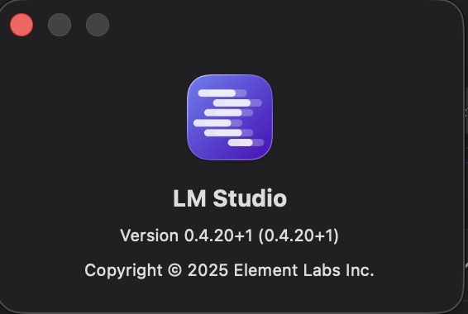 | 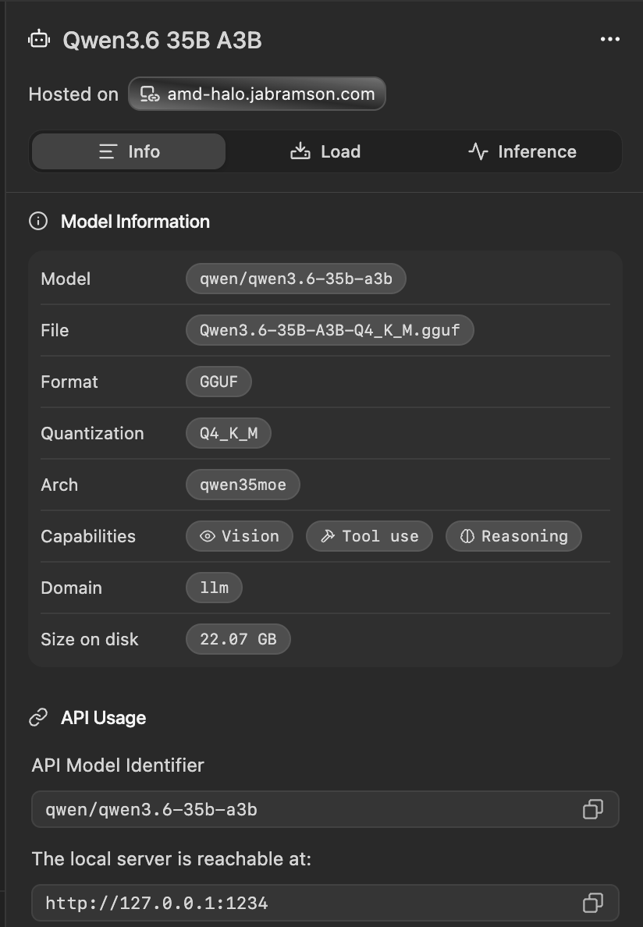

Appendix B – Claude Code Specification

Version: 2.1.220 Session name: Plan RoomDB and SQLite integration for project
Session ID: cef9fb0e-88fd-40e3-90c0-24457ee46c5d
cwd: REPO_ROOT
Login method: Claude Pro account
Organization:'s Organization Email:
Model: Default (Sonnet 5 · Efficient for routine tasks)
MCP servers: 2 disabled · /mcp
Setting sources: User settings, Project local settings

Appendix C – Local Systems
Local System | AI Server System
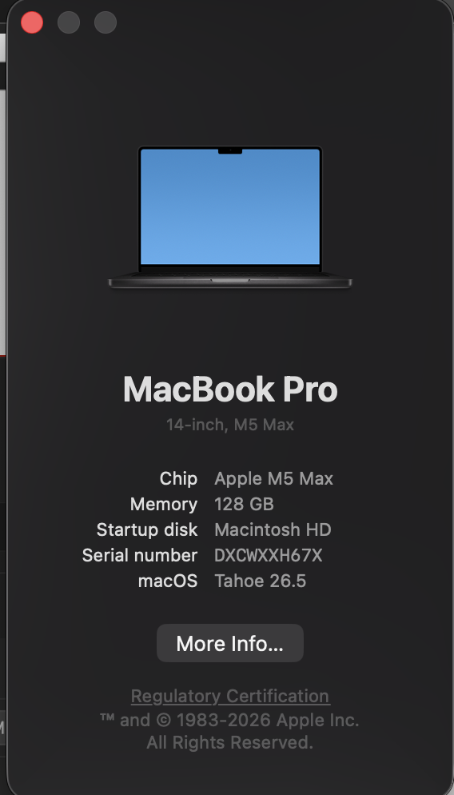 | 